**Praktikum 3 Sistem Basis Data 2023**

**NRP / Nama : Ahmad Fadhilah Mappisara  
Kelas : SBD - K**

**RDBMS : MySQL**

**Link SQL :**

**Kode Asdos : SBDK002**

**Sesi : Praktikum**

**Nomor 1**

Sintaks:

**SELECT**

P.NIK,

P.Nama **AS** Customer_Name,

P.Asal_Kota **AS** Customer_City

**FROM**

Pelanggan P

**JOIN**

Transaksi T **ON** P.NIK = T.Pelanggan_NIK

**WHERE**

P.Membership_ID **IS** **NOT** **NULL**

**AND** T.Waktu_Mulai > '2023-01-01 08:00:00';

Hasil:

**Nomor 2**

Sintaks:

**SELECT**

C.*,

**COUNT**(T.ID) **AS** Transaction_Count

**FROM**

Cabang C

**LEFT** **JOIN**

Transaksi T **ON** C.ID = T.Cabang_ID

**GROUP** **BY**

C.ID, C.Alamat, C.Kecamatan, C.Tanggal_Pembukaan

**ORDER** **BY**

C.ID;

Hasil:

**Nomor 3**

Sintaks:

**SELECT**

P.NIK,

P.Nama **AS** Customer_Name,

P.Asal_Kota **AS** Customer_City,

P.Usia

**FROM**

Pelanggan P

**WHERE**

P.Usia > (

**SELECT**

**AVG**(**TIMESTAMPDIFF**(**YEAR**, Tanggal_Lahir, **CURDATE**()))

**FROM**

Pegawai

);

Hasil:

**Nomor 4**

Sintaks:

**SELECT**

T.Cabang_ID **AS** Branch_ID,

**GROUP_CONCAT**(S.ID) **AS** Bike_ID_List,

**COUNT**(T.ID) **AS** Brand_Transaction_Count

**FROM**

Transaksi T

**JOIN**

Sepeda S **ON** T.Sepeda_ID = S.ID

**JOIN** (

**SELECT**

T1.Cabang_ID,

S1.Merek,

**COUNT**(T1.ID) **AS** Brand_Count

**FROM**

Transaksi T1

**JOIN**

Sepeda S1 **ON** T1.Sepeda_ID = S1.ID

**GROUP** **BY**

T1.Cabang_ID, S1.Merek

) **AS** BrandCount **ON** T.Cabang_ID = BrandCount.Cabang_ID **AND** S.Merek = BrandCount.Merek

**WHERE**

(S.Merek, BrandCount.Brand_Count) **IN** (

**SELECT**

Merek,

**MAX**(Brand_Count)

**FROM**

(

**SELECT**

T2.Cabang_ID,

S2.Merek,

**COUNT**(T2.ID) **AS** Brand_Count

**FROM**

Transaksi T2

**JOIN**

Sepeda S2 **ON** T2.Sepeda_ID = S2.ID

**GROUP** **BY**

T2.Cabang_ID, S2.Merek

) **AS** MaxBrandCount

**GROUP** **BY**

Merek

)

**GROUP** **BY**

T.Cabang_ID, S.Merek

**ORDER** **BY**

T.Cabang_ID;

Hasil:

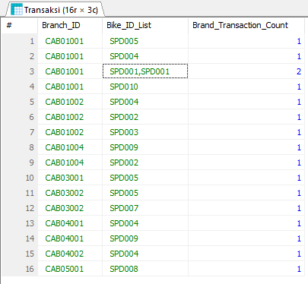

**Nomor 5**

Sintaks:

**SELECT**

P.Nama **AS** Customer_Name,

P.Membership_ID,

**COUNT**(T.ID) **AS** Total_Transactions

**FROM**

Pelanggan P

**JOIN**

Transaksi T **ON** P.NIK = T.Pelanggan_NIK

**JOIN**

Membership M **ON** P.Membership_ID = M.ID

**WHERE**

**DATE**(M.Tanggal_Pendaftaran) = **DATE**(T.Tanggal_Sewa)

**GROUP** **BY**

P.NIK, P.Membership_ID

**ORDER** **BY**

Total_Transactions **DESC**;

Hasil:

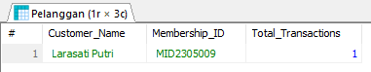

**Nomor 6**

Sintaks:

**SELECT**

P.Nama **AS** Employee_Name,

P.Tanggal_Mulai_Bekerja **AS** Start_Date,

**COUNT**(T.ID) **AS** Number_of_Transactions

**FROM**

Pegawai P

**JOIN**

Transaksi T **ON** P.ID = T.Pegawai_ID

**WHERE**

**YEAR**(P.Tanggal_Mulai_Bekerja) = 2023

**GROUP** **BY**

P.ID, P.Nama, P.Tanggal_Mulai_Bekerja

**ORDER** **BY**

Number_of_Transactions **DESC**;

Hasil:

**Nomor 7**

Sintaks:

**SELECT**

S.Jenis **AS** Bike_Type,

**COUNT**(T.ID) **AS** Number_of_Bikes_Rented

**FROM**

Sepeda S

**JOIN**

Transaksi T **ON** S.ID = T.Sepeda_ID

**WHERE**

**MONTH**(T.Tanggal_Sewa) = **MONTH**(**CURRENT_DATE**())

**AND** **YEAR**(T.Tanggal_Sewa) = **YEAR**(**CURRENT_DATE**())

**GROUP** **BY**

S.Jenis

**ORDER** **BY**

Number_of_Bikes_Rented **DESC**;

Hasil:

**Nomor 8**

Sintaks:

**SELECT**

P.Nama **AS** Customer_Name,

P.Nomor_Telepon **AS** Phone_Number,

P.Membership_ID

**FROM**

Pelanggan P

**JOIN**

Transaksi T **ON** P.NIK = T.Pelanggan_NIK

**JOIN**

Sepeda S **ON** T.Sepeda_ID = S.ID

**WHERE**

S.Jenis = 'Gunung'

**GROUP** **BY**

P.NIK, P.Nama, P.Nomor_Telepon, P.Membership_ID

**HAVING**

**COUNT**(T.ID) > 1;

Hasil:

**Nomor 9**

Sintaks:

**SELECT**

T.ID **AS** Transaction_ID,

T.Tanggal_Sewa **AS** Rental_Date,

**TIMESTAMPDIFF**(**HOUR**, T.Waktu_Mulai, T.Waktu_Selesai) **AS** Rental_Duration,

S.Jenis **AS** Bike_Type,

(**TIMESTAMPDIFF**(**HOUR**, T.Waktu_Mulai, T.Waktu_Selesai) * S.Harga_Sewa_Per_Jam) **AS** Total_Rental_Cost

**FROM**

Transaksi T

**JOIN**

Sepeda S **ON** T.Sepeda_ID = S.ID

**WHERE**

**TIMESTAMPDIFF**(**HOUR**, T.Waktu_Mulai, T.Waktu_Selesai) > (

**SELECT**

**AVG**(**TIMESTAMPDIFF**(**HOUR**, Waktu_Mulai, Waktu_Selesai))

**FROM**

Transaksi

)

**ORDER** **BY**

Rental_Duration **DESC**;

Hasil:

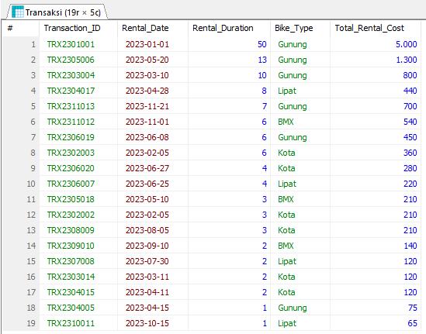

**Nomor 10**

Sintaks:

**SELECT**

Cabang_ID **AS** Branch_ID,

**COUNT**(ID) **AS** Number_of_Transactions

**FROM**

Transaksi

**GROUP** **BY**

Cabang_ID

**HAVING**

**COUNT**(ID) = (

**SELECT**

**MIN**(TransactionCount)

**FROM** (

**SELECT**

Cabang_ID,

**COUNT**(ID) **AS** TransactionCount

**FROM**

Transaksi

**GROUP** **BY**

Cabang_ID

) **AS** BranchTransactionCounts

);

Hasil:

